**Category 5e Shielded Keystone Jack**

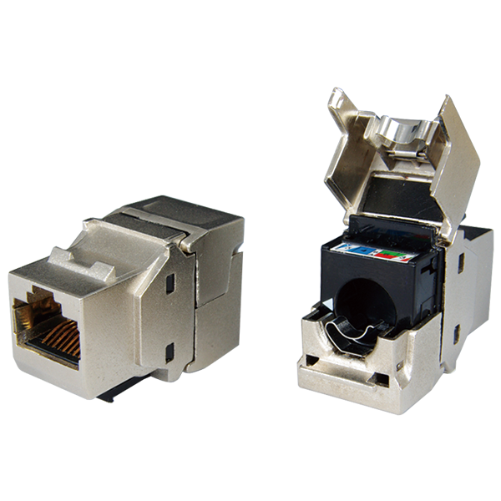

Category 5e metal-shielded keystone jack is designed for superior performance and easy assembly. Meets ANSI/TIA-568.2-D and ISO/IEC 11801 2nd edition Category 5e standard.

## **Features**

Zinc-alloy metal shell

Contacts are phosphor bronze plated with 50 micro inches hard gold

Dual T568A &amp; T568B wiring

Polycarbonate 94V0 rated

UL Listed

Itertek ETL / Force EC Cat.6A VERIFIED

4PPoE compliant in accordance with IEEE802.bt Type 4

**Ordering Information**

|  |  |
| --- | --- |
| **Part No.** | **Description** |
| **1A58TPZe0** | RJ45, 8-Conductor Cat.5e, Tool-free, Shielded, 180 degree, H.D. version |
| **2A58KPSe0** | RJ45, 8-Conductor Cat.5e, KRONE/110 IDC, Shielded, 180 degree, H.D. version |
| **1K5800Se0** | RJ45, 8-Conductor Cat.5e, 110 IDC, Shielded, 90 degree |
| **2K58TPZe0** | RJ45 8-Conductor Cat.5e, KRONE/110 IDC, Shielded, 90 degree, Short depth design, L=29.86mm |